IT24104353

Lab 06

Karunarathna H.W.D.S.S

1.

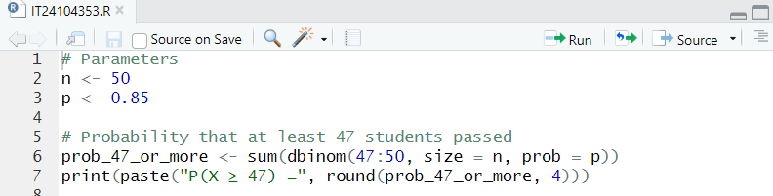

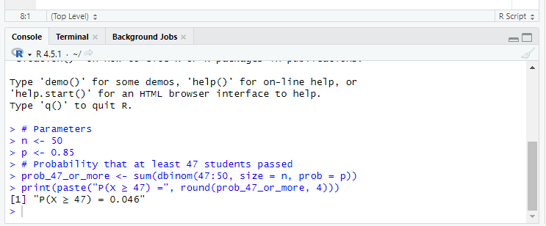

2.

